
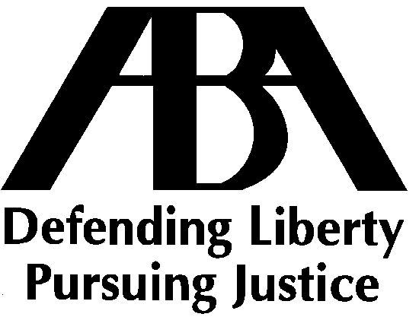The American Bar Association
Section of Litigation
Presents a 60-Minute Litigation Series
Live Webcast and Audio Teleconference
The Use of Electronic Search Tools and Experts in Discovery
Tuesday, December 9, 2008
1:00 PM – 2:00 PM Eastern | 12:00 PM – 1:00 PM Central | 11:00 AM – 12:00 PM Mountain | 10:00 AM – 11:00 AM Pacific
Program Description  Recent federal court decisions have raised significant concerns for parties relying on electronic search tools for collecting and producing documents, including identifying potentially privileged documents to be withheld from production, pursuant to Rule 26(b)(5). Three decisions are of particular interest:  - U.S. v. O’Keefe, decided by Magistrate Judge John M. Facciola (who is also on the panel), suggests a need for linguists, statisticians, and computer experts to help determine and conduct appropriate searches  - Victor Stanley, Inc. v. Creative Pipe, Inc. is less stringent, but still requires searches to be designed by “qualified persons” and requires that counsel demonstrate adequate quality assurance  - Equity Analytics v. Lundin, also decided by Judge Facciola, relied upon a forensic examiner to determine the scope and sufficiency of certain e-discovery efforts  These decisions have garnered much attention – and concern – due to the increasingly common practice of relying upon electronic search tools to substantially cut the costs of and expedite the review and production of electronically stored information (ESI).  This teleconference and live audio webcast will help shed light on what these, and other, decisions mean for the use of electronic search tools and the need for “e-discovery experts” in litigation and offer some important guidelines on how to satisfy counsel’s discovery and ethical obligations when preserving, collecting, and producing ESI.  Our Expert Faculty  Magistrate Judge John M. Facciola, United States District Court for the District of Columbia, Washington, DC  David D. Cross, Crowell & Moring, LLP, Washington, DC  Adam Cohen, FTI Consulting, New York, NY  Aron Raskas (Moderator), Kamon & Graham, PA, Baltimore, MD | TeleConference/Live Audio Webcast Tuition  Contact couringg@staff.abanet.org for information on group rates for this program.  Unable to Participate?  The complete program will be available on audio CD. To order, please visit: www.abaclecatalog.org (search by title or keyword).  All participants must be registered for the program. Cancellations and requests for refunds will be honored on the following basis: 2 business days or more, 100% refund; 1 business day or less, 100% refund minus a $25 administrative fee. Substitute registrants are welcome. Scholarship applications are available upon request.  CLE Credit  1.0 hours of CLE credit in 60-minute states/1.2 hours of CLE credit in 50-minute states have been requested in states accrediting ABA teleconferences and live audio webcasts. States currently not accrediting ABA Teleconferences: DE, IN, PA, KS, OH  NY-licensed attorneys:  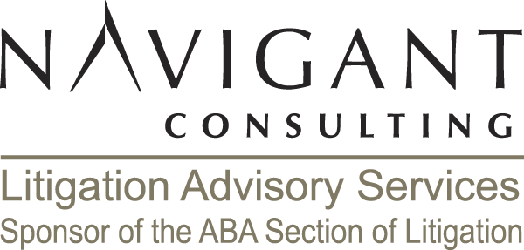  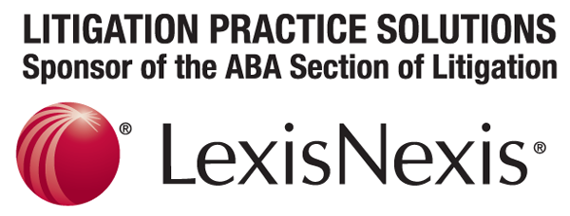  This non-transitional CLE program has been approved for experienced NY-licensed attorneys in accordance with the requirements of the New York State CLE Board for 1.0 total NY CLE credits.
  $35 | Section of Litigation Members
  $80 | ABA members (includes program participation and enrollment in the Section of Litigation—a $90 value)
  $150 | All other registrants

Register Today

Online at http://www.abanet.org/cle/programs/l08tue1.html
Phone: 800.285.2221 and Select Option “2”, M-F, 8:30 AM - 6:30 PM Eastern
Review the ABA Section of Litigation program calendar at http://www.abanet.org/litigation/programs
Event Code: CEL8TUE | Source Code: TCE08FTUE1
If you would prefer not to receive information about ABA-CLE programs via fax, dial 866.322.3158 and enter 38160 followed by your fax number.
Or check the box to your left, write your name and fax number above, and fax this page to 800.208.0584.

