The Export Practitioner and Washington Tariff & Trade Letter

Present a

Live Audio-Conference Briefing on

CFIUS and the Next Wave
of Foreign M&A

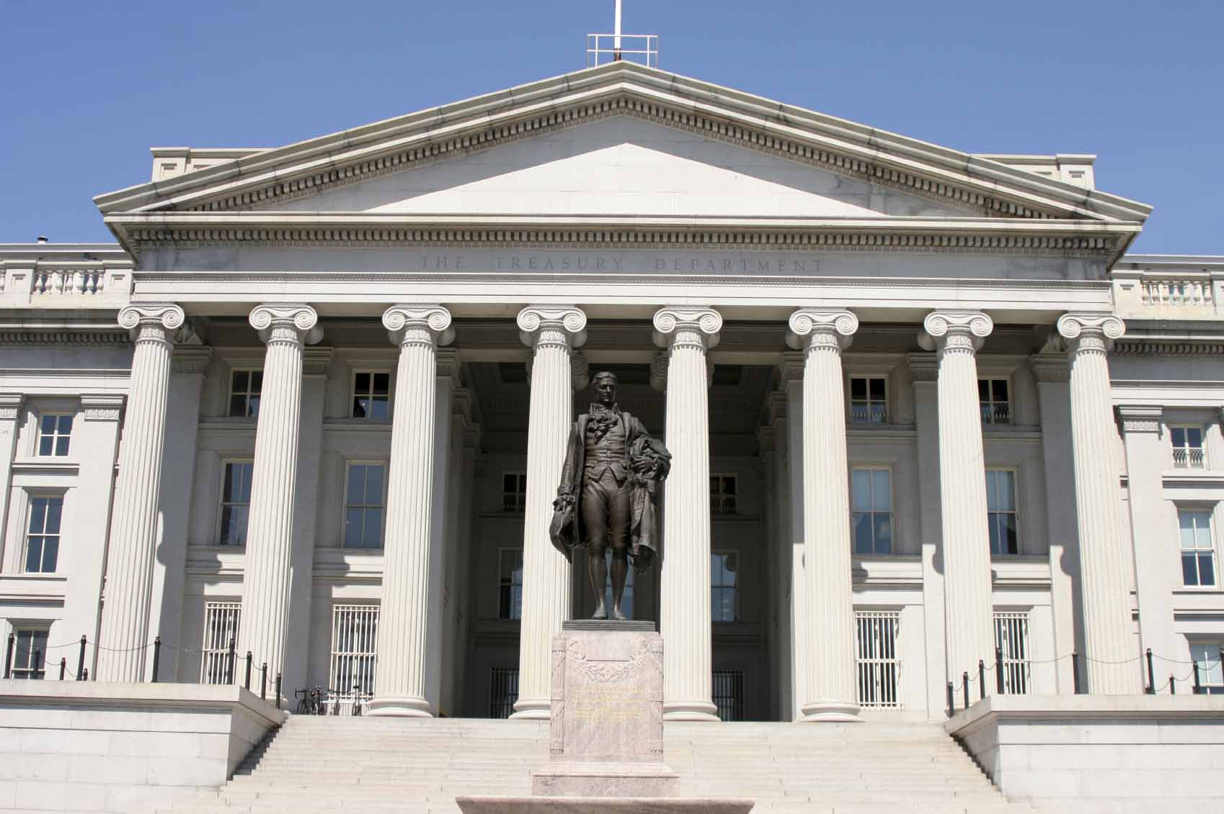

Over the course of 2007 and 2008, major changes were made to the statute, regulations and executive order that govern national security reviews by the interagency Committee on Foreign Investment in the U.S. (CFIUS). Those changes may face significant tests in the near future. With the decline in the market capitalization of many U.S. companies during the current recession and growing foreign holdings of U.S. dollars, a new wave of investments, mergers and acquisitions by foreign buyers, especially from China, India and the Middle East, may be coming. How will CFIUS balance the U.S. commitment to an open investment policy in the face of intensified national security concerns? This timely and valuable audio-conference briefing will give you an insider’s understanding of the CFIUS process and what you must know about it in order to navigate successfully a foreign acquisition of a U.S. company. Our expert speakers were central figures in drafting the new CFIUS regulations and the executive order, as well as the guidance on national security reviews issued concurrently with the regulations. They have had extensive experience with the CFIUS review process under both the old rules and the new rules.

Featured Speakers

Nova J. Daly
Public Policy Consultant
Wiley Rein LLP

Theodore R. Posner
Partner
Thursday,
October 15, 2009

2:00 to 3:30 P.M. (Eastern)
1:00 to 2:30 P.M. (Central)
12:00 Noon to 1:30 P.M. (Mountain)
11:00 A.M. to 12:30 P.M. (Pacific)
Crowell & Moring LLP

REGISTER NOW:
CALL: 202-463-1250, Ext.193
FAX: 301-570-4545
ONLINE: www.exportprac.com

WHO SHOULD SIGN UP?

- Corporate General Counsels
- Senior Management
- Merger & Acquisition Managers
- International Trade Lawyers
- Ethics and Compliance Managers
- International Accountants and Auditors
- Export Compliance Directors
- Chief Technology Officers
- VPs International
- Foreign Investors
- Sovereign Wealth Fund Managers
- International Financiers and Bankers
CONVENIENCE OF
AUDIO-CONFERENCE

- Listen from Your Own Office
- Let Staff Join On Speaker Phone
- No Limit on Listeners Per Line
- Add to Your Training Program
- Get to Ask Questions Directly
- Hear From Compliance Experts
- Avoid Travel and Hotel Costs
- No Time Lost out of Your Office
- Hear Concerns of Other Exporters
- Receive Slides and PowerPoints
- Learn How Rules Are Interpreted
- Fit into Your Busy Schedule

ABOUT OUR SPEAKERS

Nova J. Daly

Mr. Daly is a consultant on international investment and trade with the Wiley Rein law firm in Washington, DC. In that position, he provides clients with both high-level insight and deep operational expertise to help them navigate the policy and regulatory environment for cross-border business activities. Before joining the firm, Mr. Daly was the Deputy Assistant Secretary for Investment Security & Policy at the Treasury Department from 2006 to 2009. In that capacity, he directed and coordinated the CFIUS process, managing the reviews of over 350 transactions worth over $300 billion, including sovereign wealth fund investments. He oversaw the interagency reform of CFIUS and managed the development, coordination, and approval of the new CFIUS regulations and guidance. Mr. Daly also developed, advocated and implemented the government’s strategy for CFIUS reform legislation. From 2004 to 2006, he was director for international trade at the National Security Council in the White House where he developed and coordinated U.S. policy on trade and investment matters. Earlier, he was the senior trade policy advisor to the Secretary at the Commerce Department and was a trade advisor on the Senate Finance Committee staff from 2002 to 2003. Mr. Daly holds a B.A. from the University of California, Irvine, and an M.A. from the School of International Service at American University.

Theodore R. Posner

Mr Posner is a partner in the international trade and international dispute resolution group in the Washington, D.C. office of law firm Crowell & Moring. His practice covers international arbitration, strategic counseling related to international trade and investment agreements and legislation and national security reviews by the Committee on Foreign Investment in the United States (CFIUS). Prior to joining Crowell & Moring in February 2009, he served as director for international trade and investment at the National Security Council (NSC) in the White House where he played a central role in developing the regulatory framework governing CFIUS reviews after enactment of the Foreign Investment and National Security Act of 2007. Before joining the NSC, Mr. Posner was on the legal staff of the U.S. Trade Representative’s office. From 1999 to 2001, he was international trade counsel to Rep. Sander M. Levin (D-Mich.). He then became international trade counsel to the Senate Finance Committee and was instrumental in drafting and securing passage of the Trade Act of 2002. Before his government service, he practiced law in Washington and New York, working on both international trade and commercial litigation matters. He received his B.A. summa cum laude from Princeton University and his J.D. from the Yale Law School, where he was an essays editor on the Yale Law Journal.

How Will Changes in the Rules Governing CFIUS National Security Reviews Affect Foreign Investment in the U.S.?

Sign Up for this Timely Audio-Conference Briefing and Learn:

- How the CFIUS Review Process Works in Practice.

  - What is the basic process for a review and investigation?
  - Who are the CFIUS agencies and how to engage them?

- What Constitutes National Security and What May Constitute a Threat to National Security.

  - How have views of what is encompassed by “national security” broadened over time, especially since September 11, 2001?
  - What light does the November 2008 guidance shed on the kinds of transactions that have raised national security considerations?

- What Factors CFIUS Is Using to Determine Whether a Transaction Is a “Covered Transaction” that May Be Subject to a National Security Review.

  - How is CFIUS answering such important threshold questions as: (1) who constitutes a “foreign person?” (2) who constitutes a “person engaged in interstate commerce in the United States?” and (3) what constitutes “control?”
  - How do CFIUS regulations address these questions?
  - What are the circumstances in which rights attributable to minority shareholders are considered not to confer control and circumstances in which they are considered to confer control?

- How the New Rules Have Changed the CFIUS Process.

- How did the January 2008 executive order change CFIUS procedures, including with respect to the mitigation of perceived threats to the national security?
- How did these changes affect the way CFIUS operates, the dynamics within CFIUS and communication between CFIUS and parties to transactions?

- How CFIUS Reviews Relate to Other Investment-Related Review Processes to Which the Same Transaction May Be Subject.

- What other regulatory regimes look at the impact foreign investment in the United States may have on national security?
- How do other processes interact with CFIUS reviews?
- What do investors and lawyers need to know about this relationship?
- How have changes in CFIUS rules affected national security reviews under these other regimes?



ABOUT THE SPONSORS

The Export Practitioner

This monthly magazine is the only publication devoted exclusively to the export licensing requirements and enforcement policies of Commerce, State and Treasury. It provides exclusive in-depth news and analysis aimed at helping exporters speed their products to customers abroad while avoiding costly legal troubles. With special guest features and columns written by experts in the field, The Export Practitioner gives export managers, international trade lawyers, and trade consultants information they can apply directly to coping with U.S. export controls and trade sanctions. For more information, visit www.exportprac.com.

Washington Tariff & Trade Letter

This award-winning weekly newsletter provides exclusive, behind-the-scenes news and analysis of Washington’s trade policies and legislation, export controls, trade sanctions, and enforcement of antidumping and countervailing duty laws. Based on nearly 30 years of experience and extensive sources in the U.S. government, Congress and diplomatic corps, it delivers a concise briefing on bilateral and multilateral trade negotiations, particularly at the WTO, and trade disputes that directly affect international trade and investment. To learn more, go to www.WTTLonline.com.

CFIUS and the Next Wave
of Foreign M&A

An Audio-Conference Briefing
Thursday, October 15, 2009
2:00 to 3:30 P.M. (Eastern)
1:00 to 2:30 P.M. (Central)
12:00 Noon to 1:30 P.M. (Mountain)
11:00 A.M. to 12:30 P.M. (Pacific)

SUBSCRIBERS SAVE 15% ON PRICE OF AUDIO-CONFERENCE
(Non-Subscribers, call today to subscribe at special discount rate.)

Please Complete and Return this Information to Register:

 Yes, Please register me for the October 15, 2009, 90-minute Audio-Conference Briefing on CFIUS and the Next Wave of Foreign M&A for $197.
 I’m a subscriber to The Export Practitioner or Washington Tariff & Trade Letter; sign me up at 15% discount
price of $167.
 I can’t participate but send me a CD recording of program for  $150 (subscriber);  $180 (non-subscriber).
 Payment Enclosed (check payable to Gilston-Kalin Communications)
 Charge my Credit Card: VISA   MasterCard  American Express   Discover 

Card Number _____________________________________________Expiration Date___________/___________

Signature _________________________________ E-Mail Address______________________________________

Name____________________________________________Title_______________________________________

Company____________________________________________________________________________________

Address____________________________________________City________________State____Zip___________

Phone_________________________________________Fax__________________________________________

❑ Please send me information about future audio-conferences and seminars on U.S. export controls.
4 EASY WAYS TO REGISTER:

- BY MAIL

- BY FAX

- BY PHONE

↓ ONLINE

EP

MAIL TO:
Gilston-Kalin Communications
P.O. Box 5325
Rockville, MD 20843-5345

FAX TO: 301-570-4545

CALL: 202-463-1250, Ext. 193

ONLINE at www.exportprac.com

