To view this email online, please click here.

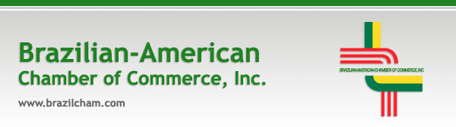
Economic Conference - Monday, October 13, 2008

2008 Brazil Economic Conference  Brazil's rise to investment grade status and its swift financial development are spawning an age of unparalleled growth and opportunity.  The 2008 Brazil Economic Conference will look at Brazil's recent economic success and examine the economic direction of the exciting B in BRICs.  Investors will gain valuable insight on how best to take advantage of the abundant opportunities to be found in Latin America's largest economy.  Register before September 12, 2008 and take advantage of our early bird registration rate!  2008 Brazil Economic Conference  Monday, October 13, 2008  8:00 AM – 3:00 PM  The Mayflower Hotel  1127 Connecticut Avenue NW  Washington, DC  Speakers Include:  - H.E. Antonio de Aguiar Patriota, Brazilian Ambassador to the United States  - H.E. Henrique Meirelles, Governor of The Central Bank of Brazil  - Mr. Luciano Coutinho, President of BNDES  - H.E. Guido Mantega, Finance Minister of Brazil  To Register:  Click here to register online or click here to download the registration form.  Sponsorship and table reservations:  Please call the Chamber’s Executive Director, Sueli Bonaparte, at 212-751-4691 or email sueli@brazilcham.com.  Please forward this notice to your colleagues and business associates.  Disregard this message if you have already registered.
  Upcoming Events
  SAVE THE DATE! Investing in Brazil's Agriculture: An Overview of an Emerging Market
  October 8, 2008
  SAVE THE DATE! Private Equity in Brazil
  November 13, 2008
  In The Spotlight
  In 2003 Goldman Sachs released a report predicting that Brazil, Russia, India and China would become four of the most dominant global economies by 2050. “Dreaming with BRICs: the Path to 2050”, theorized that together these emerging markets could potentially grow larger in US dollar terms than all of the G6 countries combined. Half a decade later, the BRIC nations seem set not only to meet these growth predictions, but to significantly surpass them. In May 2008 the BRIC foreign ministers held their very first stand-alone meeting, in Yekaterinburg, Russia, marking the increased momentum behind their economies and signaling a new phase for the future of the BRICs.
  Chamber members can read more about this timely topic in the most recent issue of the Brazil Business Report . For more information on the benefits of Chamber membership, click here.
Brazilian-American Chamber of Commerce, Inc.  509 Madison Avenue, Suite 304  New York, NY 10022  Tel: 212-751-4691  Fax: 212-751-7692  www.brazilcham.com | Mailing List:  Click here to join our mailing list.  To change your email address, go here.  Let us know if you would like to unsubscribe.

